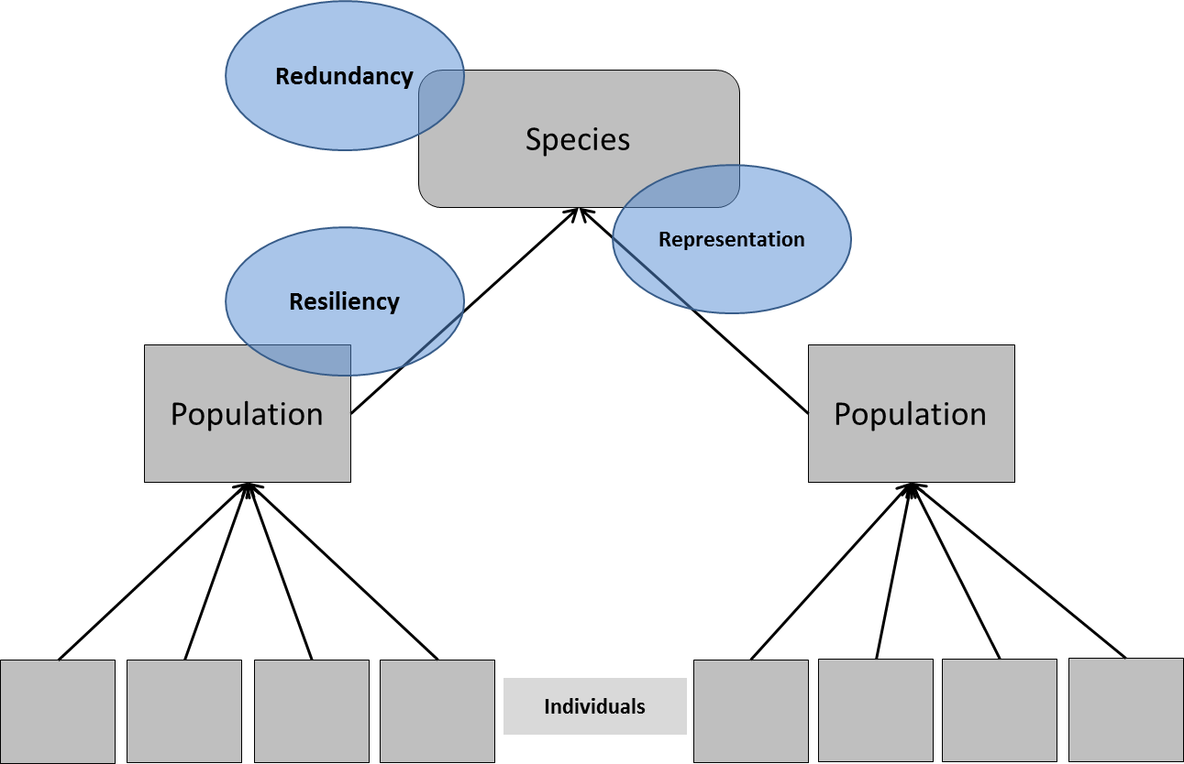

Figure 4. Resiliency is measured at the population level, representation is measured at the species and, possibly, population level, and redundancy is measured at the species level. In practice the 3Rs are interrelated – resiliency supports redundancy, representation supports resiliency, etc.